

**Adding image files**

**To CodeX**

**Student Workbook**



**Displaying images on CodeX**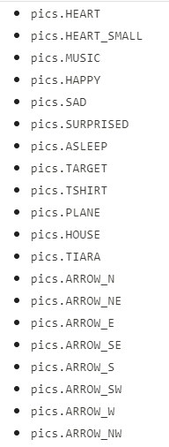

The CodeX comes with many images that are available through the codex module. They are **bitmap** images.

You might want to use your own images, which are often JPG files.

**Adding JPG image files**

* You can add images that are JPG files to your CodeX. Just follow these steps.

1. **Find an image, or use one of your own images.**
   1. You should be aware of copyright laws. If you look on the internet for images, look for creative commons or royalty free images.
   2. You should always give credit for the image in a comment in your code.
2. **Make the JPG image useable by changing the size.**

Before you can upload and use the image, it needs to be the correct size and compression.

Use [Photopea](https://www.photopea.com/) which is a free online photo editor.



1. **Open your image in Photopea**.

This is easiest if it is saved to your computer or a flash drive or Google drive for easy access.

1. **Change the image size to fit the display screen**

Follow these steps to change the size to fit the screen

* Click on **Image** – Image Size
* Change Width & Height (240x240 or smaller)
* Change the DPI to 72
* 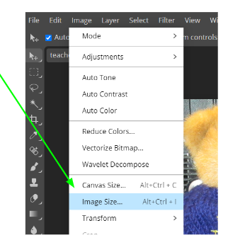The **RESAMPLE** needs to be **Bilinear**

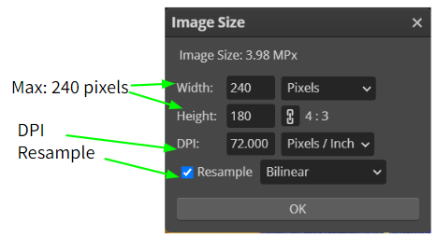

1. Export the image as a JPG

* Click on File – Export as
* Choose JPG
* Give the image a simple name  
  (no spaces)
* Save it where you can find it

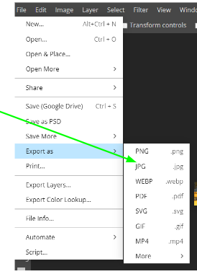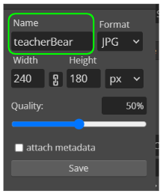

1. **Make the CodeX USB-writable**

Once the image files are ready, they need to be loaded directly onto CodeX. The Codex is read-only by default, but you can make it writable.

Watch the video or follow the steps below.

[youtube video demonstration](https://youtu.be/B21ZobkYukE)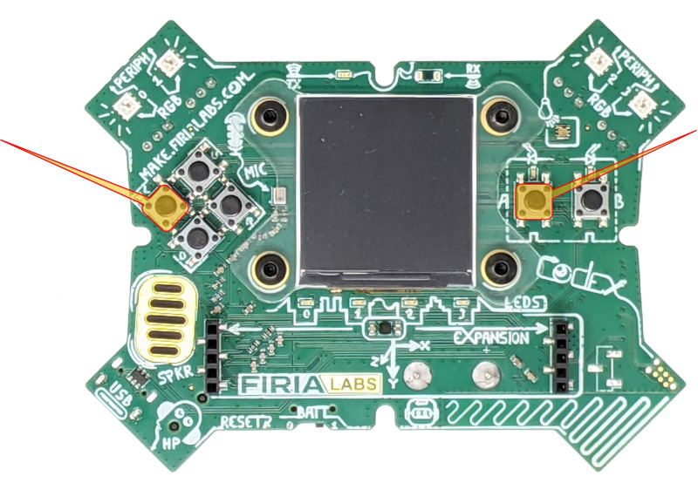

Written instructions:

* 1. Make sure the CodeX is connected to your computer with the USB cable
  2. Press and hold the **L** and **A** buttons and keep holding   
     them down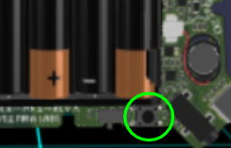
  3. Reach around and briefly press the RESET button   
     (press and release)
  4. Keep holding buttons **A** and **L** until you see the red LEDs light up from *3* to *0* in right-to-left order.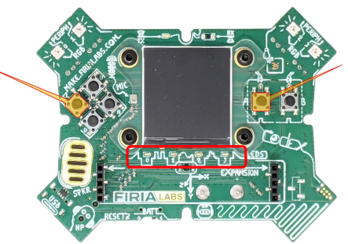
  5. You will see a *double-flash* of ALL red LEDs to confirm the filesystem is in USB-writable mode.
  6. Now release **L** and **A**.
  7. You are ready to upload your files to the Codex

7. Upload your image files to the CodeX

You can upload right to the CodeX, or you can create a folder for pics and upload there

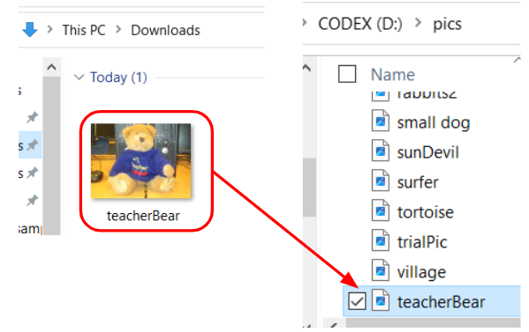

8. Make CodeX read-only again

Disconnect the CodeX from the computer (unplug the cable) and then connect it again. This returns the CodeX to read-only

9. Use the image in your program.

Use the display.draw_jpg command

